Dementia Guardian: An IoT-Based Monitoring and Assistance Device for Dementia Patients

## Barath Kumar J - CB.EN.U4CSE21608

## Shri Praveen S M - CB.EN.U4CSE21658

## Sudharshan B - CB.EN.U4CSE21661

# Objective

The objective of the Dementia Guardian project is to develop an IoT device that ensures the safety and well-being of dementia patients. The device provides continuous monitoring, real-time location updates, and assistance in case of disorientation. It aims to mitigate the risks associated with wandering and getting lost, common issues faced by dementia patients.

# Hardware Selection and Design

## Sensors, Actuators, Controller, and Communications Units

## 

* **ESP32 Microcontroller:** Chosen for its integrated Wi-Fi and Blue- tooth capabilities, low power consumption, and versatility in IoT ap- plications.
* **GPS Sensor:** Utilized to obtain real-time location data of the patient. This sensor activates when the patient presses the button on the device, providing accurate location information to the caregiver.
* **Button:** A simple input device for the patient to alert the caregiver and request assistance. Pressing the button sends the patient’s current location to the caregiver.
* **Display:** A screen to show messages to the patient, such as ”Press the button if you forget” and navigation routes to guide them home.

|  |  |
| --- | --- |
| Parameters to be Monitored | 1)GPS location (home and current)  2)Button State |
| Sensors Used | 1)Neo GPS Module  2)Push Button  3)TFT LCD Display |
| Cloud Platform | Render Cloud Service |
| Web socket Communication | 1. HTTP REST 2. FastAPI |
| Database | PostgreSQL |
| Backend /Interface | Python |

# Software Design

## Flowchart / Data Flow Diagram (DFD) / Pseudo Code

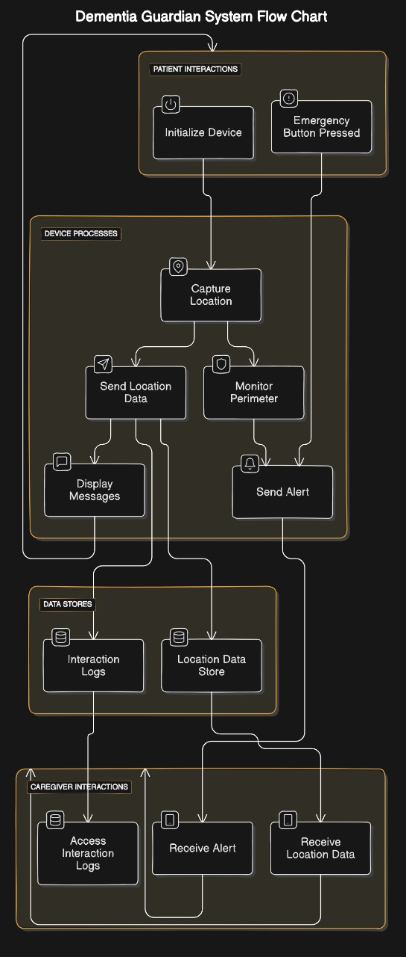

### Flowchart

1. **Start**

### Initialize ESP32, GPS, Button, and Display

1. **Patient presses button**

### a. Capture location using GPS

* + b. **Send location to caregiver via web application**

### c. Display message to patient

1. **Monitor perimeter**

### a. If patient crosses perimeter, alert caregiver

1. **Record interactions (button presses, perimeter breaches)**

### End Pseudo Code

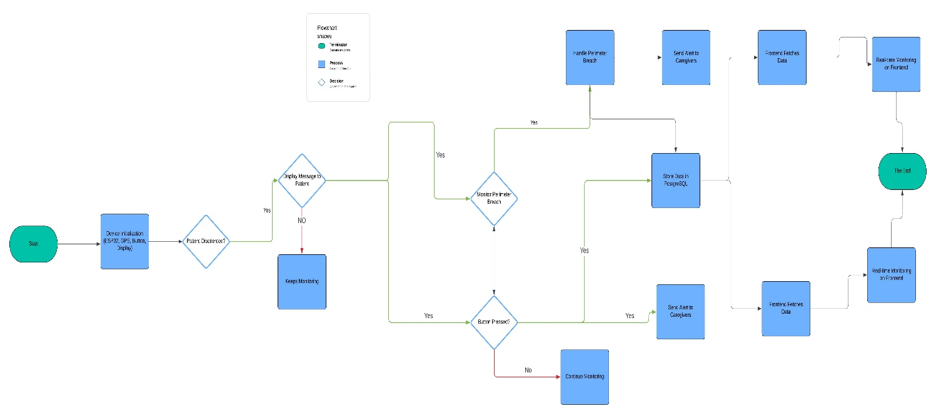

I n i t i a l i z e ESP32 , GPS, Button , Display

**while** True :

**i f** Button **i s** pre s s e d :

l o c a t i o n = GPS. g e t l o c a t i o n ()

s e n d l o c a t i o n t o c a r e g i v e r ( l o c a t i o n )

Display . show message ( ” Press - the - button - i f - you - f o r g e t ” )

**i f** p a t i e n t c r o s s e s perimeter :

s e n d a l e r t t o c a r e g i v e r ( l o c a t i o n )

**Architecture diagram:**

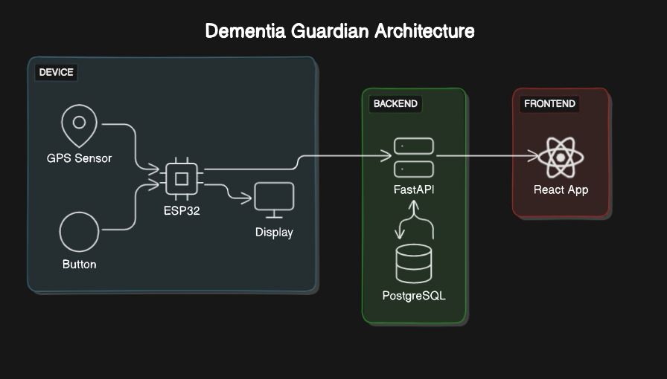

r e c o r d i n t e r a c t i o n ( ” perimeter - breach ” ) r e c o r d i n t e r a c t i o n ( ” button - p re s s ” )

**DFD Diagram:**

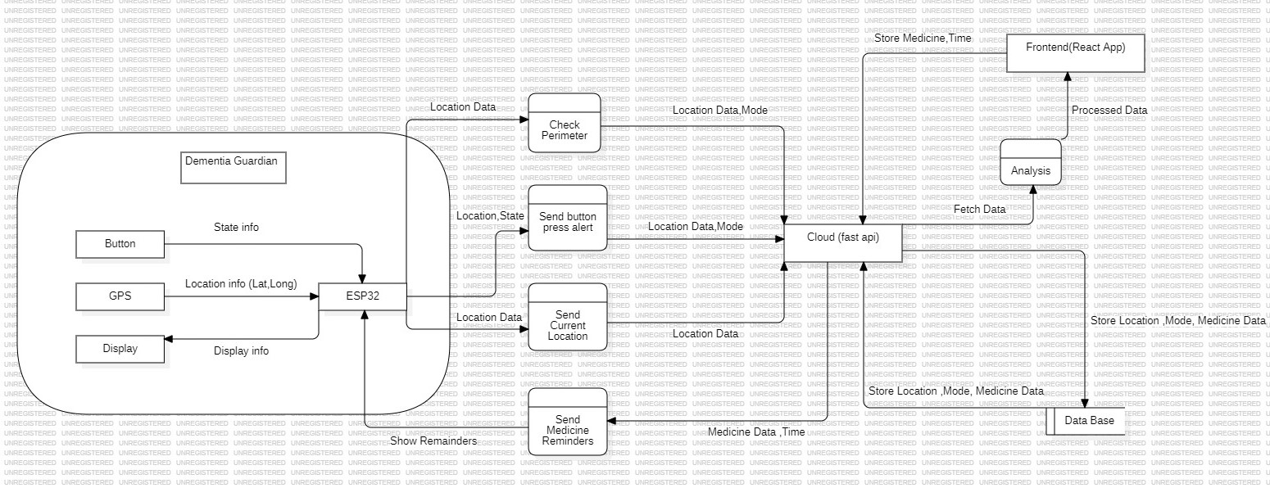

# IoT System Design (Level 5 / 6)

# 

## Level 5/6 Design

The IoT system design for the Dementia Guardian device includes:

1. **End Device (ESP32, GPS, Button, Display):** Captures and pro- cesses patient data, sends alerts, and displays messages.
2. **Edge Computing:** Processes data locally on the ESP32, reducing latency and bandwidth usage.
3. **Cloud Integration:** Uses cloud services for data storage, processing, and analysis. The web application for caregivers is hosted on the cloud, providing real-time access to patient data.

# Integration of End, Edge, and Cloud

* **End Device:** Collects data (location, button presses) and sends it to the Edge.
* **Edge Computing:** Processes data locally on the ESP32 for immediate actions (alerts, display messages).
* **Cloud:** Stores data for long-term analysis and provides a web appli- cation for caregivers to monitor patients in real-time.

# Data Accumulation and Processing

# 

* **Data Accumulation:** All interactions (button presses, perimeter breaches) are recorded and sent to the cloud.
* **Processing:** Data is processed to generate insights such as frequency of disorientation (button presses) and perimeter breaches.

# IoT Analytics

# 

# 

# 

# 

# 

* Alert Frequency over time : Tracks alerts over the whole period of time
* Alert Source distribution : pie chart of distribution between button alerts and perimeter breach.
* Time between alerts: Analyzes the alert frequency over an internal
* Daily alert patterns : Alert pattern over a daily basis
* Hourly alert trends : alerts in an hourly trends.

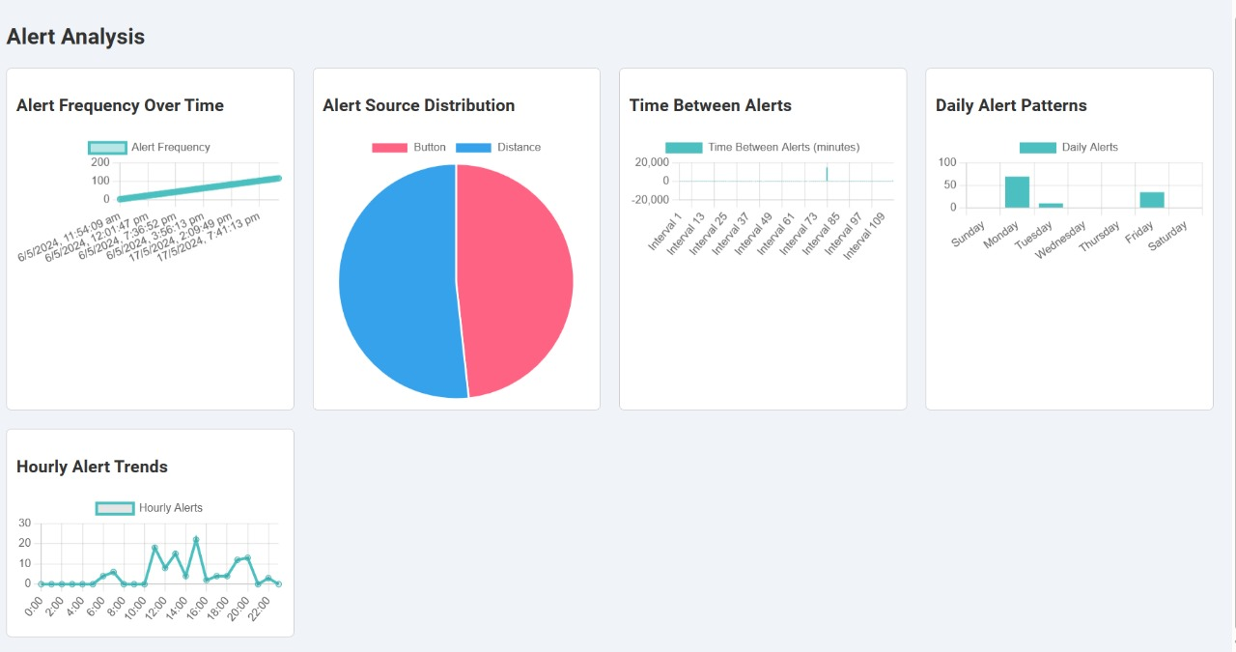

# Sample Test Cases and Reports

# 

## Test Case 1: Button Press Functionality

* **Objective:** Verify that pressing the button sends the correct location to the caregiver.

### Steps:

* 1. Patient presses the button.
  2. Check if the caregiver receives the location update.
  3. Confirm that the message is displayed on the device.
* **Expected Result:** Caregiver receives accurate location, and message is displayed.

## Test Case 2: Perimeter Breach Alert

* **Objective:** Ensure that crossing the perimeter triggers an alert to the caregiver.

### Steps:

1. Patient crosses the predefined safe perimeter.
2. Check if the caregiver receives an alert with the location.

* **Expected Result:** Caregiver receives alert with accurate location.

## Test Case 3: Data Recording

* **Objective:** Validate that all interactions are recorded accurately.

### Steps:

1. Press the button and cross the perimeter multiple times.
2. Check the recorded data in the cloud.

* **Expected Result:** All interactions are logged correctly.

**Test Case 4: Medicine Alerts**

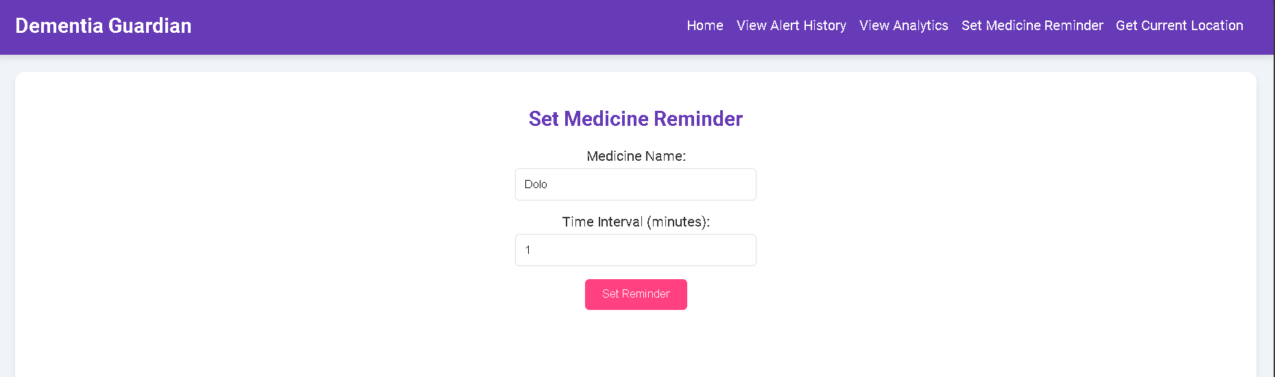

* **Objective:** Caregiver set the period of interval between timely alerts.

### Steps:

1. Set the interval and medicine names.
2. Check for alerts in hardware display when time is up.

* **Expected Result:** Repeated periodic alerts or medicine

**Test Case 5: Patient Current Location**

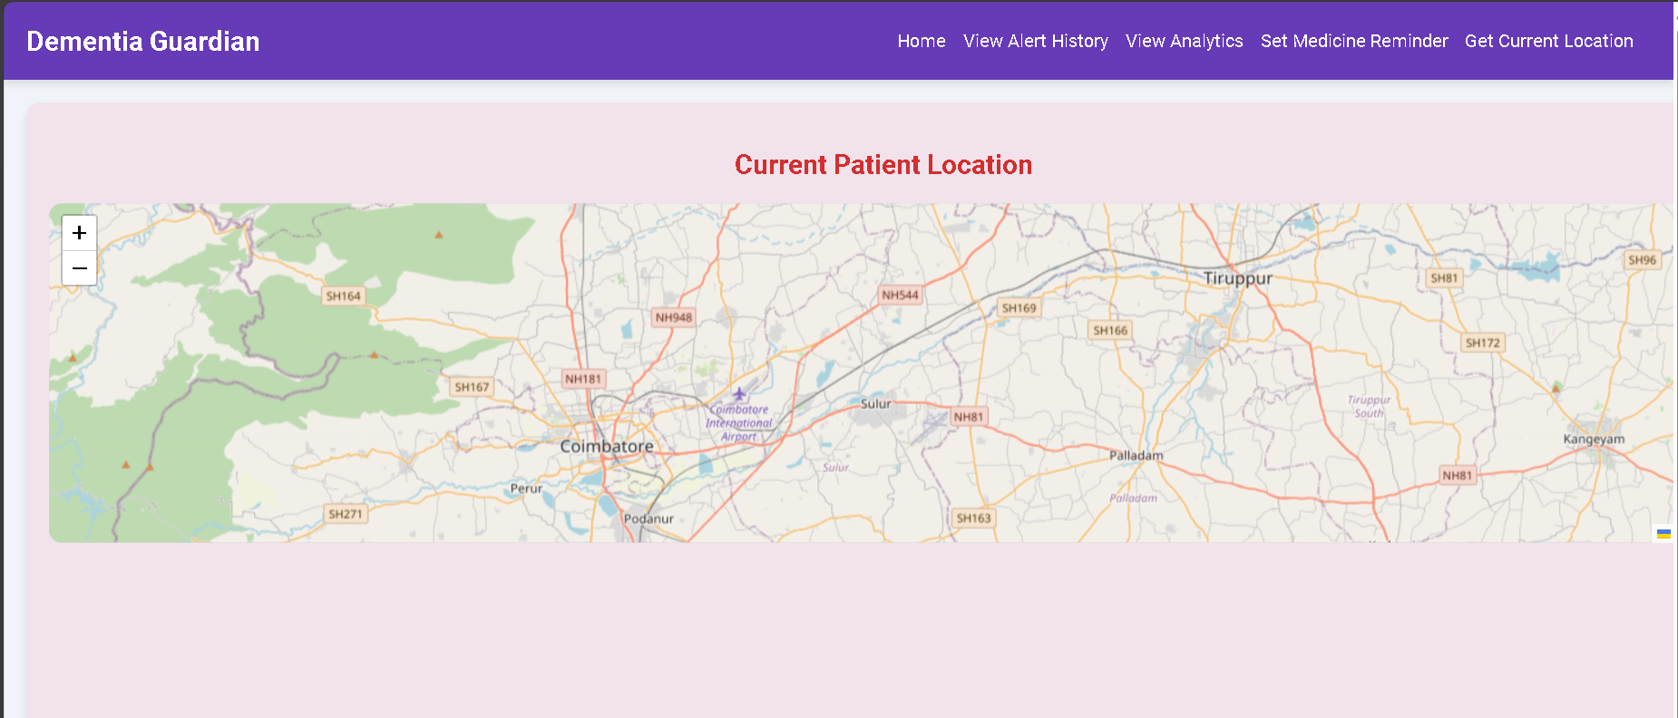

* **Objective:** To check patients current location by the caregiver at any point of time.

### Steps:

1. Patient device to be on so it can send location periodically.
2. Caregiver to check in his webapp for the current location

* **Expected Result:** Accurate realtime current location of patient.

# Outcomes

* **Real-time Monitoring:** Continuous tracking of patient location en- sures their safety.
* **Immediate Assistance:** Patients can easily request help by pressing a button.
* **Caregiver Alerts:** Instant notifications for perimeter breaches and disorientation incidents.
* **Data Insights:** Analysis of interaction data aids in understanding patient behavior and improving care.
* **Medication Reminders:** Adding functionality to remind patients of their medication schedules.
* **Monitor patient Current Location:** Caregiver can constantly check the patient’s current location

# Conclusion and Future Scope

## Conclusion

The Dementia Guardian project successfully developed an IoT device that enhances the safety and well-being of dementia patients through real-time monitoring, location updates, and caregiver alerts. The system’s ability to record and analyze patient interactions provides valuable insights for improv- ing patient care.

## Future Scope

* **Navigation Assistance:** Implementing navigation routes on the dis- play to guide patients home.
* **Task Reminders:** Integrating reminders for daily tasks and appoint- ments to further support patient independence.